MACHINE LEARNING ASSIGNMENT
Introduction:
The Smart Recipe Intelligence System is a machine learning–based web application designed to analyze recipe data and extract meaningful insights from unstructured text. The system performs three major analytical tasks:
- Health Classification (Supervised Learning)
- Cuisine Discovery (Topic Modeling – Unsupervised Learning)
- Recipe Clustering (Unsupervised Learning)
The project integrates Natural Language Processing (NLP), feature engineering, and machine learning models to transform recipe titles, ingredients, and instructions into structured predictions and intelligent insights.
Dataset Overview
The Smart Recipe Intelligence System is developed using the RecipeNLG dataset, a large-scale structured recipe corpus designed for natural language processing tasks.
The dataset contains thousands of real-world recipes including:
- Recipe Title
- Ingredients List
- Cooking Instructions
- Associated Metadata
For this project, approximately 60,000 recipes were used for supervised learning tasks and additional data for unsupervised modeling.

ALGORITHM 1: RANDOM FOREST CLASSIFIER
1. Problem Addressed
Classify recipes into:
- Healthy
- Moderately Healthy
- Unhealthy
This is a multi-class supervised classification problem.
2. Algorithm Description
Random Forest is an ensemble learning algorithm that builds multiple decision trees and combines their outputs using majority voting.
It:
- Uses bootstrap sampling.
- Selects random feature subsets.
- Reduces overfitting through averaging.
3. Reason for Choosing Random Forest
- Handles high-dimensional sparse text features (TF-IDF).
- Works well with mixed features (text + structured).
- Provides feature importance for interpretability.
- Reduces overfitting compared to a single decision tree.
- Stable and robust for large datasets (~60k recipes).
4. Performance Metrics
- Accuracy: 87.3%
- F1-Score (Healthy): 0.90
- F1-Score (Unhealthy): 0.90
- Precision and Recall balanced across classes.
ALGORITHM 2: SUPPORT VECTOR MACHINE (LINEAR SVM)
1. Problem Addressed
Classify recipes into:
- Healthy
- Moderately Healthy
- Unhealthy

2. Algorithm Description
Linear SVM finds an optimal hyperplane that maximizes the margin between classes.
It:
- Uses one-vs-rest strategy for multi-class classification.
- Works efficiently in high-dimensional spaces.
3. Reason for Choosing SVM
- Highly effective for text classification.
- Performs well with sparse TF-IDF features.
- Faster inference compared to ensemble models.
- Better generalization in high-dimensional feature space.
4. Performance Metrics
- Accuracy: 89.1%
- Higher precision compared to Random Forest.
- Better margin-based separation.
- Improved generalization.
SVM performed slightly better than Random Forest.
ALGORITHM 3: LATENT DIRICHLET ALLOCATION (LDA)
1. Problem Addressed
Discover hidden cuisine styles from recipe text without labels.
This is an unsupervised topic modeling problem.
2. Algorithm Description
LDA is a probabilistic generative model that:
- Assumes each document is a mixture of topics.
- Each topic is a distribution over words.
- Uses Dirichlet distributions to model topic probabilities.

3. Reason for Choosing LDA
- Suitable for discovering hidden themes in large text corpora.
- Provides interpretable topic-word distributions.
- Widely used for document clustering and theme extraction.
- Does not require labeled data.
4. Performance Metrics
- Number of Topics: 8
- Coherence Score: 0.524
- Topic Diversity: 0.78
- Perplexity: 1247.3
Topics identified meaningful cuisine styles such as:
- Savory dishes
- Fruit desserts
- Mediterranean meals
- Breads and pizza
- Spiced dishes
ALGORITHM 4: K-MEANS CLUSTERING
1. Problem Addressed
Group similar recipes based on textual similarity.
This is an unsupervised clustering problem.
2. Algorithm Description
K-Means partitions data into K clusters by:
- Initializing K centroids.
- Assigning points to nearest centroid.
- Recomputing centroids.
- Repeating until convergence.
Uses Euclidean distance in vector space.
3. Reason for Choosing K-Means
- Efficient for large datasets.
- Works well with TF-IDF vectors.
- Simple and interpretable.
- Computationally scalable.
- Suitable for similarity-based grouping.
4. Performance Metrics
- Number of Clusters: 10
- Silhouette Score: 0.387
- Davies-Bouldin Index: 1.42
- Calinski-Harabasz Index: 8934.2
Clusters formed meaningful groups such as:
- Tropical desserts
- Chicken dishes
- Chocolate treats
- Mediterranean meals
- Casseroles and soups
Preprocessing Flow
Preprocessing converts raw recipe text into structured numerical features suitable for machine learning models.
2.1 Lowercasing
What it is:
Conversion of all text into lowercase.
What is done:
Example:
“Chicken Soup” → “chicken soup”
Why it is used:
To ensure uniformity and prevent the model from treating “Chicken” and “chicken” as different words.
2.2 Removal of Special Characters (Regex Cleaning)
What it is:
Using Regular Expressions to remove punctuation, numbers, and unwanted symbols.
What is done:
Example:
“Bake at 180°C for 30 mins!” → “bake at c for mins”
Why it is used:
To remove noise and keep only meaningful textual content.
2.3 Tokenization
What it is:
Breaking text into individual words (tokens).
What is done:
“add sugar and milk” →
[“add”, “sugar”, “and”, “milk”]
Why it is used:
Machine learning models process text at word level, so tokenization converts sentences into analyzable units.
2.4 Stopword Removal
What it is:
Removal of common words that do not contribute meaningful information.
Examples of stopwords:
- and
- the
- is
- at
- on
What is done:
[“add”, “sugar”, “and”, “milk”] →
[“add”, “sugar”, “milk”]
Why it is used:
To reduce dimensionality and remove unnecessary words that do not influence classification.
2.5 Lemmatization
What it is:
Reducing words to their base or root form using linguistic rules.
What is done:
“cooking”, “cooked”, “cooks” → “cook”
Why it is used:
To reduce vocabulary size and group similar word forms under a single base term.
2.6 Text Reconstruction
What it is:
After cleaning and lemmatization, tokens are combined back into a sentence.
Why it is used:
Vectorizers like TF-IDF and CountVectorizer require text input in string format.
2.7 TF-IDF Vectorization
What it is:
Term Frequency–Inverse Document Frequency is a numerical representation of text.
What is done:
- Convert text into numerical vectors.
- Maximum 5000 features used.
- Measures importance of words relative to the dataset.
Why it is used:
- Highlights important distinguishing words.
- Works very well for text classification.
- Reduces effect of commonly occurring words.
Used for:
- Random Forest
- SVM
- K-Means Clustering

2.8 Count Vectorization
What it is:
Converts text into word frequency counts.
What is done:
Counts number of occurrences of each word.
Why it is used:
LDA requires raw frequency counts rather than TF-IDF.
Used for:
- Latent Dirichlet Allocation (Topic Modeling)
2.9 Structured Feature Extraction
In addition to text features, structured numerical features were added:
- Number of ingredients
- Instruction length
- is_baked (binary feature)
- is_fried (binary feature)
- is_grilled (binary feature)
- is_steamed (binary feature)
Why it is used:
These features help health classification by providing cooking-method and complexity indicators.
2.10 Feature Concatenation
What is done:
Combine:
- 5000 TF-IDF features
- 6 structured features
Total Features = 5006
Why it is used:
To allow models to learn from both textual and numerical information.

Web Application:
The Smart Recipe Intelligence System is deployed as an interactive web application built using Streamlit, a Python-based web framework for machine learning applications.
The web application allows users to:
- Enter a recipe title
- Enter ingredients
- Enter cooking instructions
- Select classification model (Random Forest / SVM)
- View health prediction
- View cuisine topic distribution
- View cluster similarity
The interface enables real-time machine learning predictions without requiring technical knowledge from the user.
Technology Stack
Frontend & UI
- Streamlit (Web framework)
- Plotly (Interactive visualizations)
Backend & ML
- Python
- Scikit-learn
- NLTK
- Pandas & NumPy
Model Storage
- Pickle (.pkl files)

SYSTEM ARCHITECTURE:
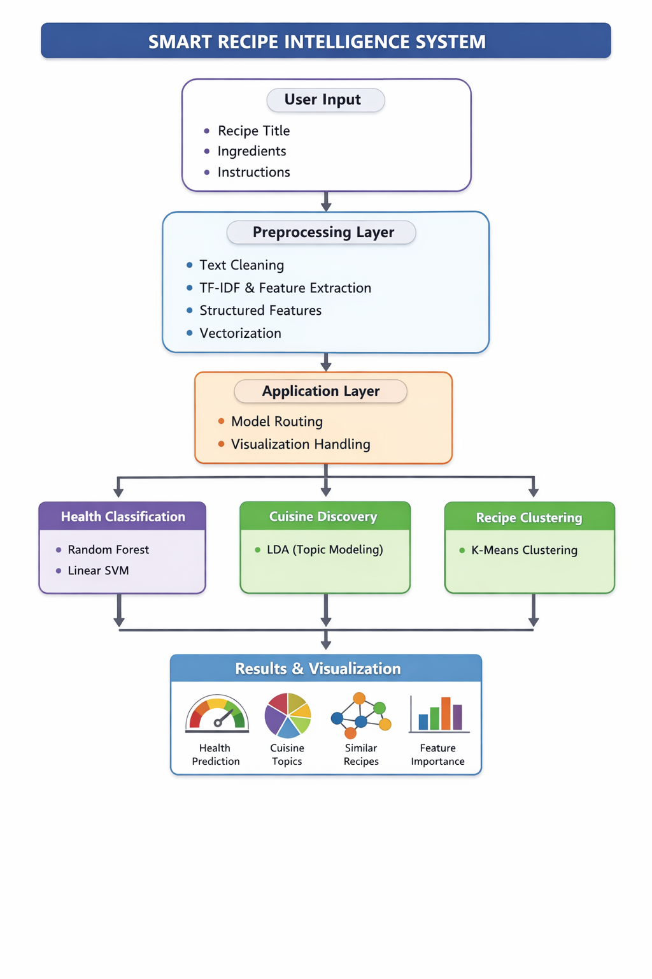

OUTPUT:
